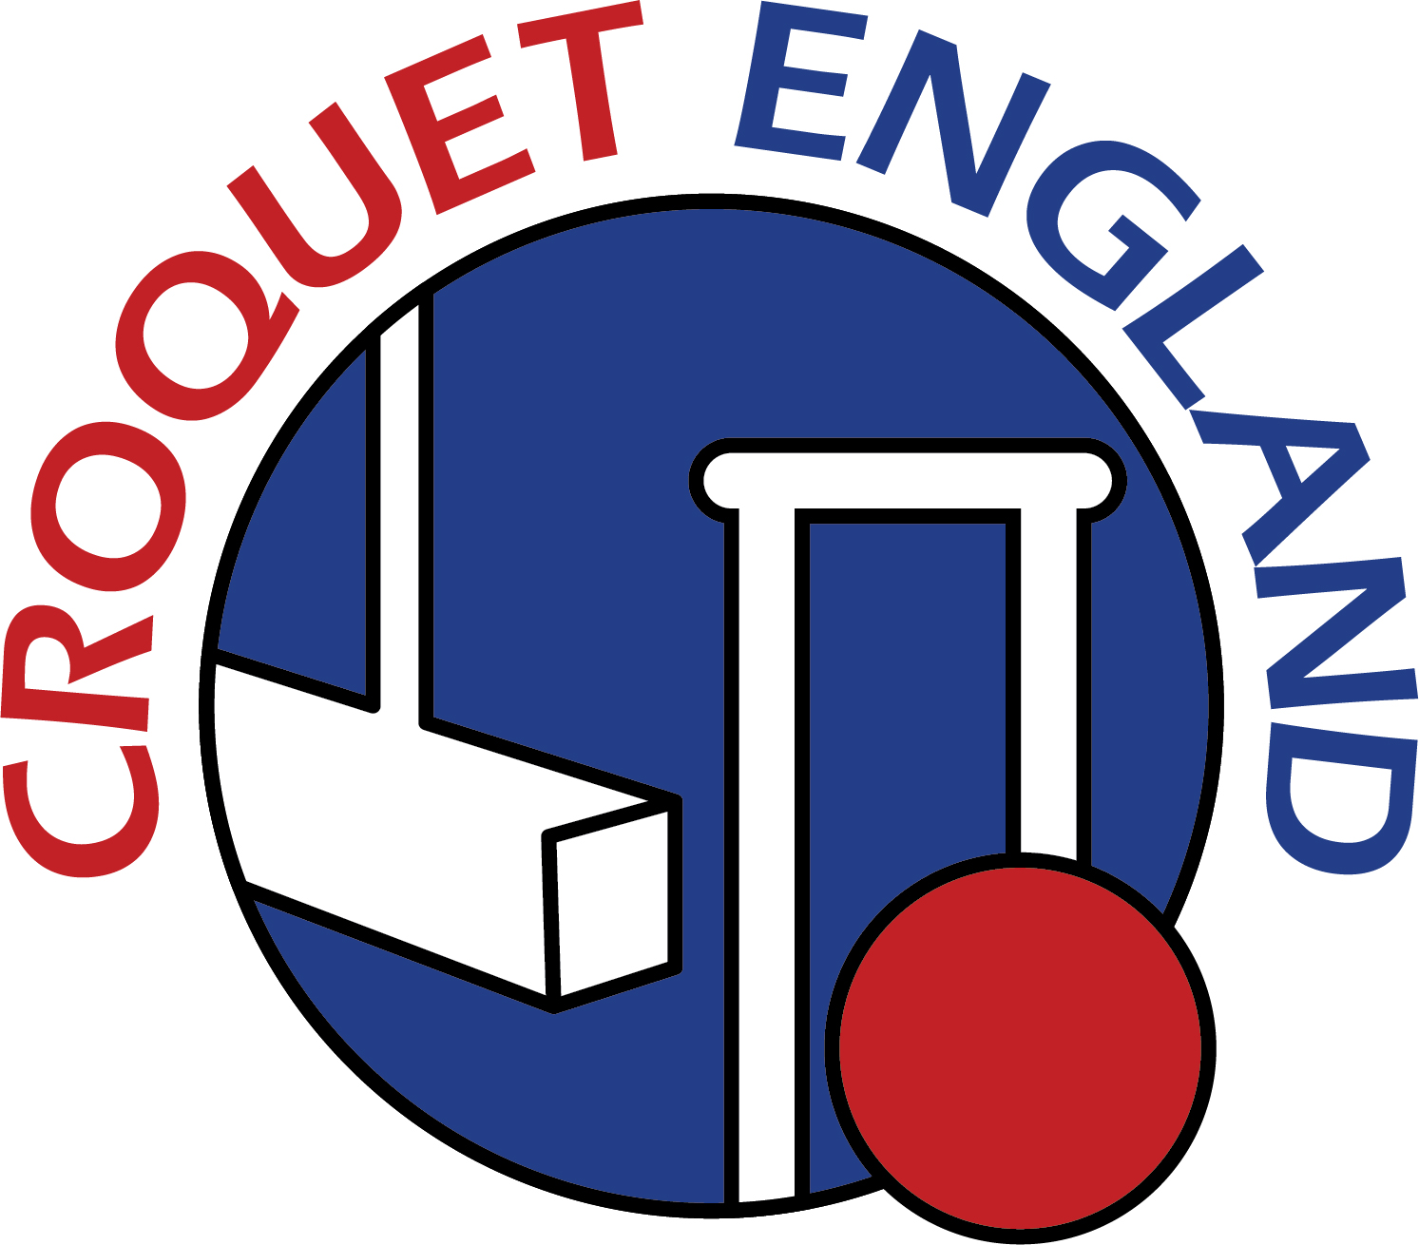

Application form for a new Member Club
(Delete whichever is not applicable)

From.........................................................................................Croquet Club

The annual fee for an Associated Club of Croquet England is as follows:
£5.00 per playing junior member
£11.50 per playing member of a club with fewer than 2 lawns
£17.50 per playing member of a club with 2 or more lawns
There is a minimum club fee of £62.

There is also a maximum fee of £62 in the first year of membership, £93 in the second year and £124 in the third year.

The annual fee for a University or School Club is £40.

CLUB FEE

Please find enclosed a cheque for (circle whichever is applicable)

Associated Club £62

University/School Club £40

Or pay by bank transfer to the account below

Croquet England
Sort Code: 80-22-60
Account Nº: 25330067

On behalf of .............................................................. Croquet Club,

Signed ............................................. Date .......................

Return to:

The Operations Manager
Croquet England
Old Bath Road
CHELTENHAM
GL53 7DF

 | Details | Any Changes
Club Address

Club Telephone

Club Email

Website

Club Secretary
Name
Address
Email
Telephone
Club Treasurer
Name
Address
Email
Telephone
Club Chairman
Name
Address
Email
Telephone
No of lawns (full size)

